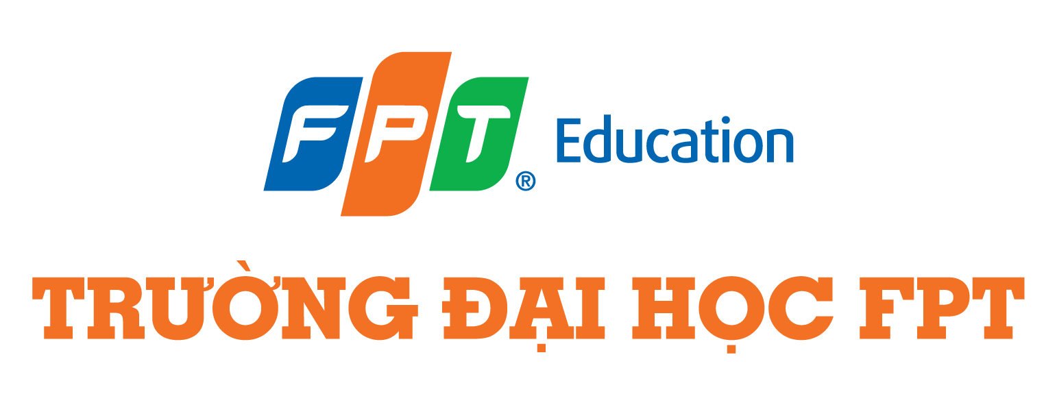

CAPSTONE PROJECT REPORT
Sales and Distribution
User Manual Report

Document information
Project Name | VinaTech Smart Manufacturing's order status management system
Module
Created by | SangNV
Version | 1.0
Date | 29/04/2026

Table of Content
I. Master Data 2
1. Create Customer 2
1.1 Domestics Wholesale Customer 3
2. Create Pricing Condition 13
II. Process Execution 19
1. Direct Sales Process 19
1.1 Create Sales Order 19
1.2 Create Outbound Delivery 24
1.3 Post Good Issue OD 28
1.4 Create Invoice 29
1.5 Receive Payment 30
2. Sales Return - Different Period 34
2.1 Create Sales Order 34
2.2 Create Outbound Delivery 36
2.3 Post Good Issue OD 40
2.4 Create Invoice 41
2.5 Receive Payment 43
2.6 Create Sales Return 47
2.7 Create Return Delivery 51
2.8 Post Goods Receipt 55
2.9 Check Billing Document 56
2.10 Remove Billing Block 58
2.11 Create Invoice 60
2.12 Receive Payment 62
3. Sales Return - Same Period 65
3.1 Create Sales Order 65
3.2 Create Outbound Delivery 68
3.3 Post Good Issue OD 72
3.4 Create Invoice 73
3.5 Create Sales Return 75
3.6 Create Return Delivery 79
3.7 Post Goods Receipt 83
3.8 Check Billing Document 84
3.9 Remove Billing Block 86
3.10 Create Invoice 88
3.11 Receive Payment 90

Master Data

1. Create Customer

1.1 Domestics Wholesale Customer
Step 1: In the Create Business Partner pop-up, choose Organization.
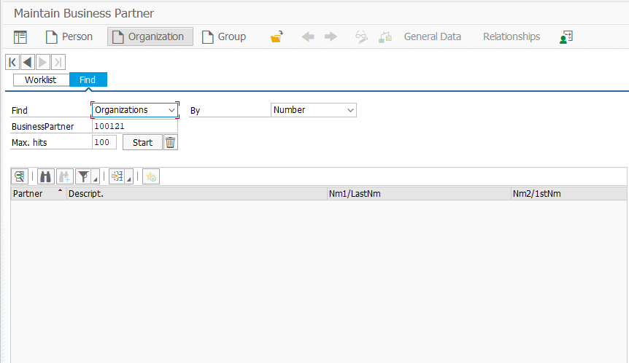
Step 2: In the Create Organization: Role FI Customer screen; make sure that for the Create in BP role FI Customer (New) is selected.
Step 3: Fill information as following:

Attribute | Data value
Title | Company
Name | Công ty TNHH Kỹ thuật mạch Đa tầng
Search Term | KTDT
Street | 125 Nguyễn Văn Linh
Postal Code | 100000
City | Ha Noi
Country | VN
Region | HN
Language | Vietnamese
Telephone | 02435121056
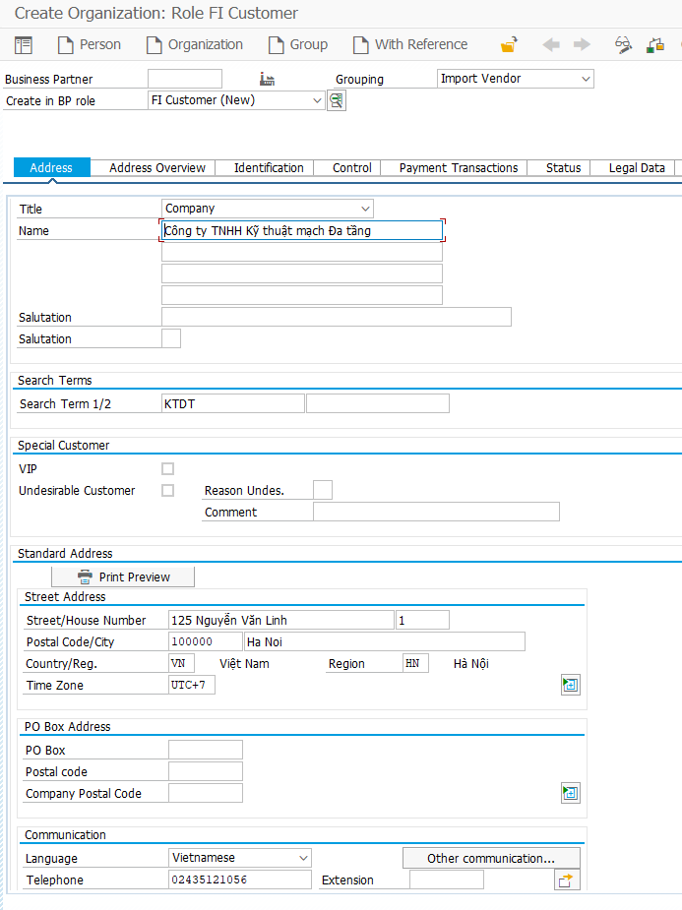

Step 4: In Identification tab, enter VN0 for Category and 304421306 for Tax Number Long.
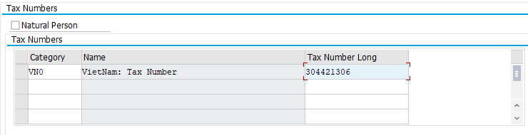
Step 5: In the Create Customer: FI Customer Role click on Company Code.
Step 6: In the Customer: Account Management tab enter 13100 for Reconciliation acct. and 001 for Sort key.
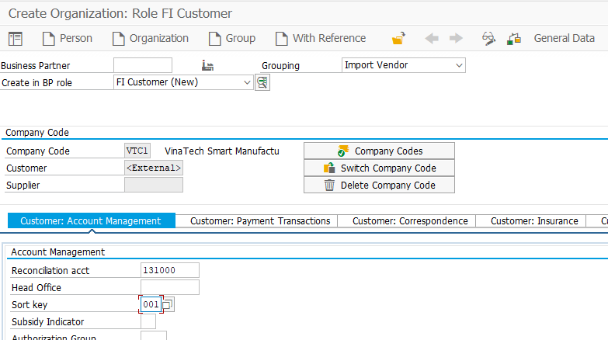
Step 7: Click on the tab Customer: Payment Transactions and enter ZVT1 for terms of Payment and I for Payment Methods. Confirm by clicking on .
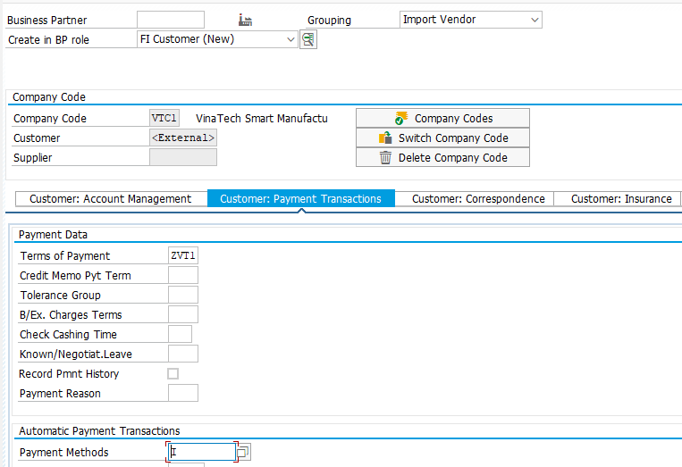
Step 8: In the Create in BP role: field, select Customer from the drop down menu.
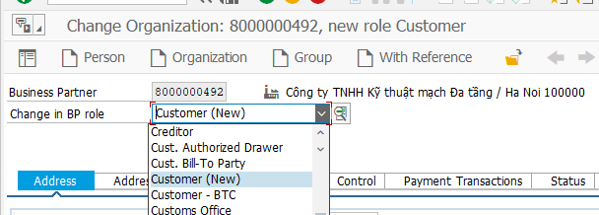
Step 9: In the Change to another BP role in create mode pop-up, click on.
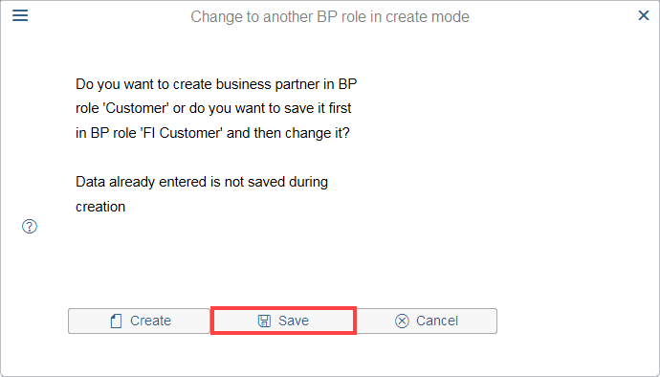
Step 10: In the Change Person: 8000000026,new role Customer clicks on Sales and Distribution.
Step 11: Click on and enter BC00 for Sales Org., WH for Distr. Channel and 99 for Division. Press Enter to confirm. Enter VN0002 for Sales District, 08 for Customer Group and BTC2 for Sales Office.
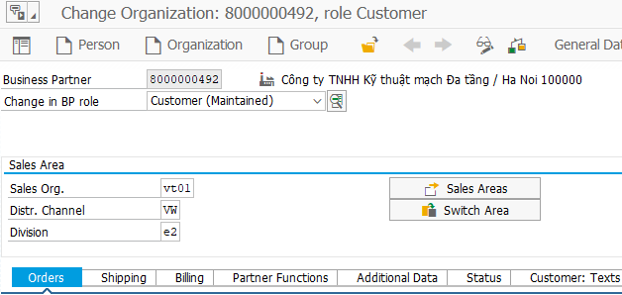
Step 12: Check that VND is entered for Currency.
Step 13: In the Pricing/Statistics, enter 01 for Price Group, VT for Cust.Pric.Proceduce and 01 for Price List.
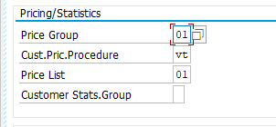
Step 14: Click on the Shipping tab and enter 02 for Delivery Priority, VTHN for Delivering Plant, 01 for Shipping Conditions.
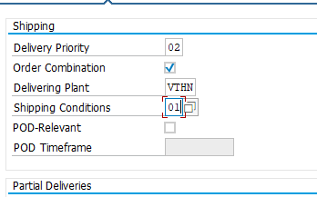
Step 15: Navigate to the Billing tab and enter ZEV for Incoterms,, ZVT1 for Payment Terms,ZVT1 for Credit Control Area, 01 for Acct Assmt Grp Cust. and 1 for Tax classific.
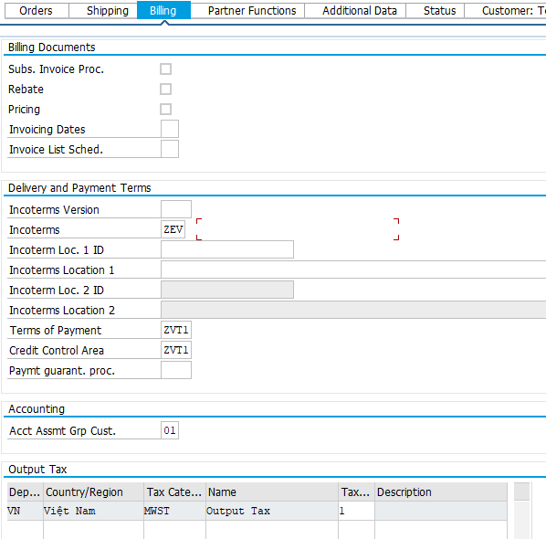
Step 16: Click on .
Step 17: You will receive a message that says 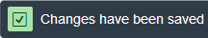.
Step 18: Click on 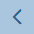 to return to the SAP Easy Access menu.
Sale&Distribution | Address | Name | Code | Description
Sale Area | Hà Nội | Sales Organization: | VT01 | VinaTech Smart Manuf
 |  | Distr. Channel: | VW | VinaTech Wholesale
 |  | Division: | CB | Circuit Board
 |  |  | E2 | Electronic Component
 | Bình Dương | Sales Organization: | VT01 | VinaTech Smart Manuf
 |  | Distr. Channel: | VW | VinaTech Wholesale
 |  | Division: | CB | Circuit Board
 |  |  | E2 | Electronic Component
 | Hồ Chí Minh | Sales Organization: | VT01 | VinaTech Smart Manuf
 |  | Distr. Channel: | VW | VinaTech Wholesale
 |  | Division: | CB | Circuit Board
 |  |  | E2 | Electronic Component
Order |  | Sale District | VN0001 | Northside Vietnam
 |  |  | VN0002 | Central Vietnam
 |  |  | VN0003 | Southside Vietnam
 |  | Currency | VND | Vietnamese Dong
 |  | Price Group | 01 | Bulk buyer(WH)
 |  |  | 02 | Occasional buyer ( R )
 |  | Cust.Pric.Procedure | VT | VinaTech Smart
Shipping |  | Delivery Plant | VTHN | Plant Ha Noi
 |  |  | VTBD | Plant Binh Duong
 |  |  | VTHC | Plant Ho Chi Minh
 |  | Shipping Conditions | 01 | Standard
Billing |  | Incoterms | ZEV | Vietnam Incoterms
 |  | Incoterms Location 1 |  | Hà Nội
 |  | Terms of Payment | ZVT1 | Payment immediately due net
 |  | Acct Assmt Grp Cust. | 01 | Domestic Revenues

2. Create Pricing Condition
The selling prices are different from moving average prices within your material master data. Moving average prices are updated from buying the material (procurement). They are the average costs that we pay for an item. Pricing is used to determine the amount of internal costs and overall prices for customers or vendors
In the SAP Easy Access menu, follow the menu path:
SAP menu ► Logistics ► Sales and Distribution ► Master Data ► Conditions ► Create
T-Code: VK11
Condition type | Copy from Condition type | Description
ZBBP | PR00 | Base Price
ZDIS | K007 | Customer Discount
MWST | MWST | Output Tax

Step 1: In the screen Create Condition Records, fill Condition type by image below:
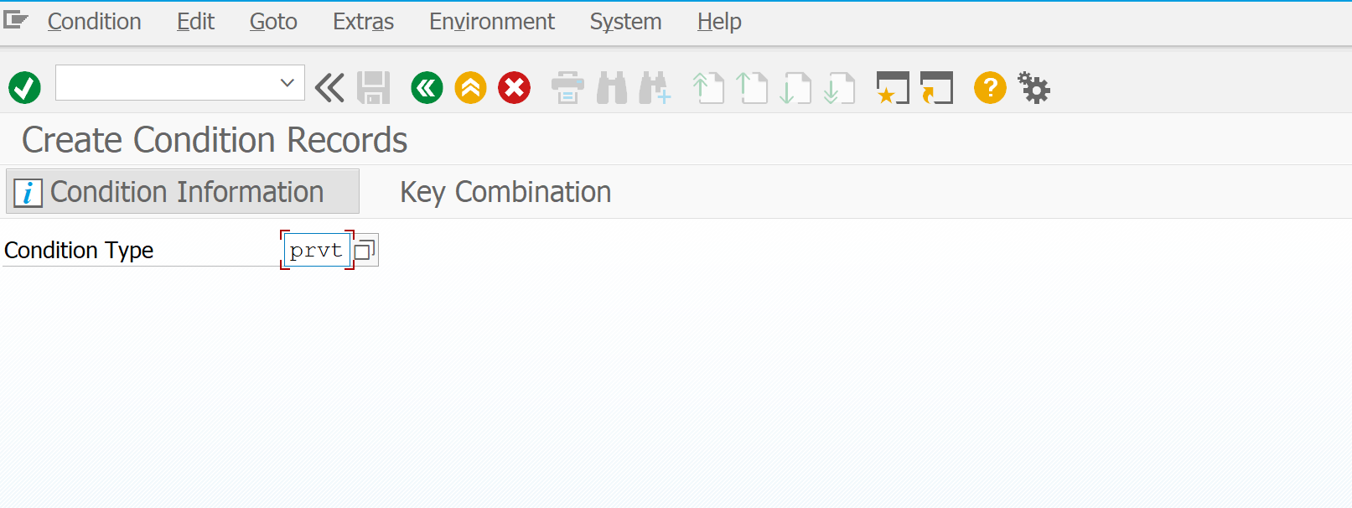
Step 2: In the Key Combination, click on Material with release status then click .
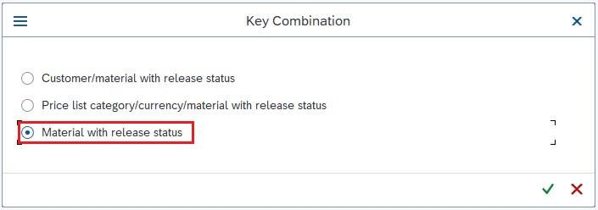
Step 3: Fill information follow below:
Attribute | Data Value
Condition Type | Base Price (ZBBP)
Sales Organization | VinaTech Smart Manuf (VT01)
Distribution Channel | Wholesale (VW)
Document Currency | Viet Nam Dong (VND)
Material | 650
Amount | 50,000,000
*Check price in this link
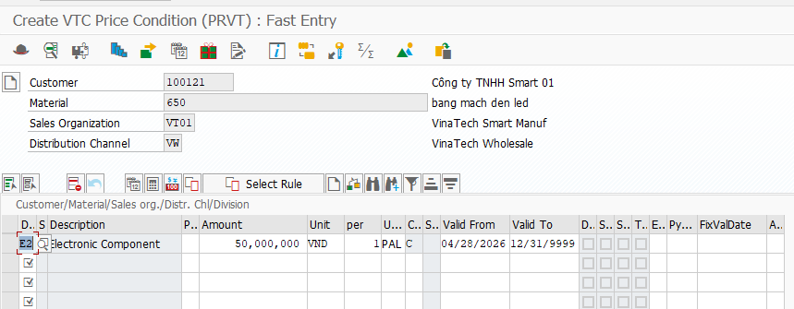
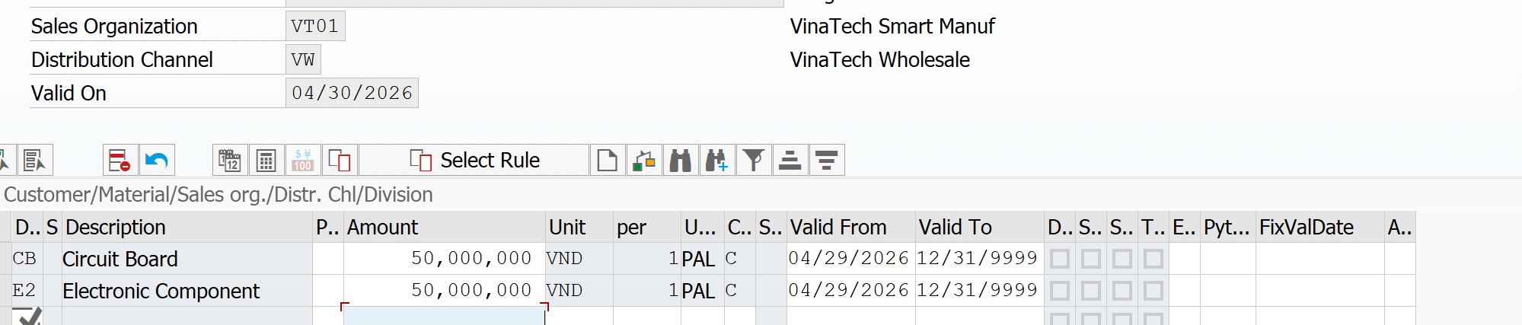

Attribute | Data Value
Condition Type | VTC Price (PRVT)
Sales Organization | VinaTech Smart Manuf (VT01)
Distribution Channel | Wholesale (WH)
Document Currency | Viet Nam Dong (VND)
Material | 650
Amount | 50,000,000
Valid from | 04/21/2026
Term of payment | Pay immediately w/o deduction (ZVT1)

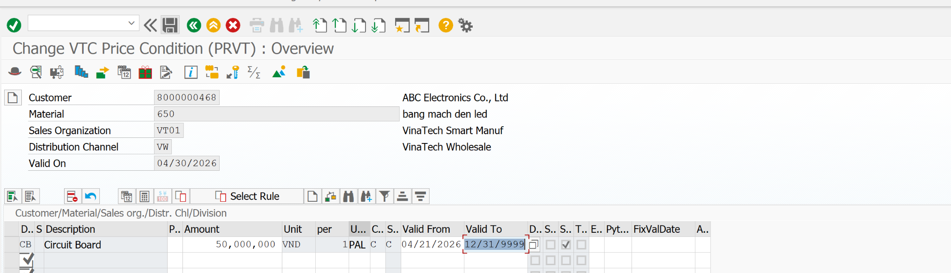
Step 4: Click on 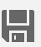. You will receive a message that says .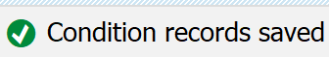
Step 5: Click on 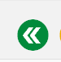 to return to the SAP Easy Access menu.
Step 6: In the Create Condition Records screen, enter PRVT for Condition Type the click Enter.
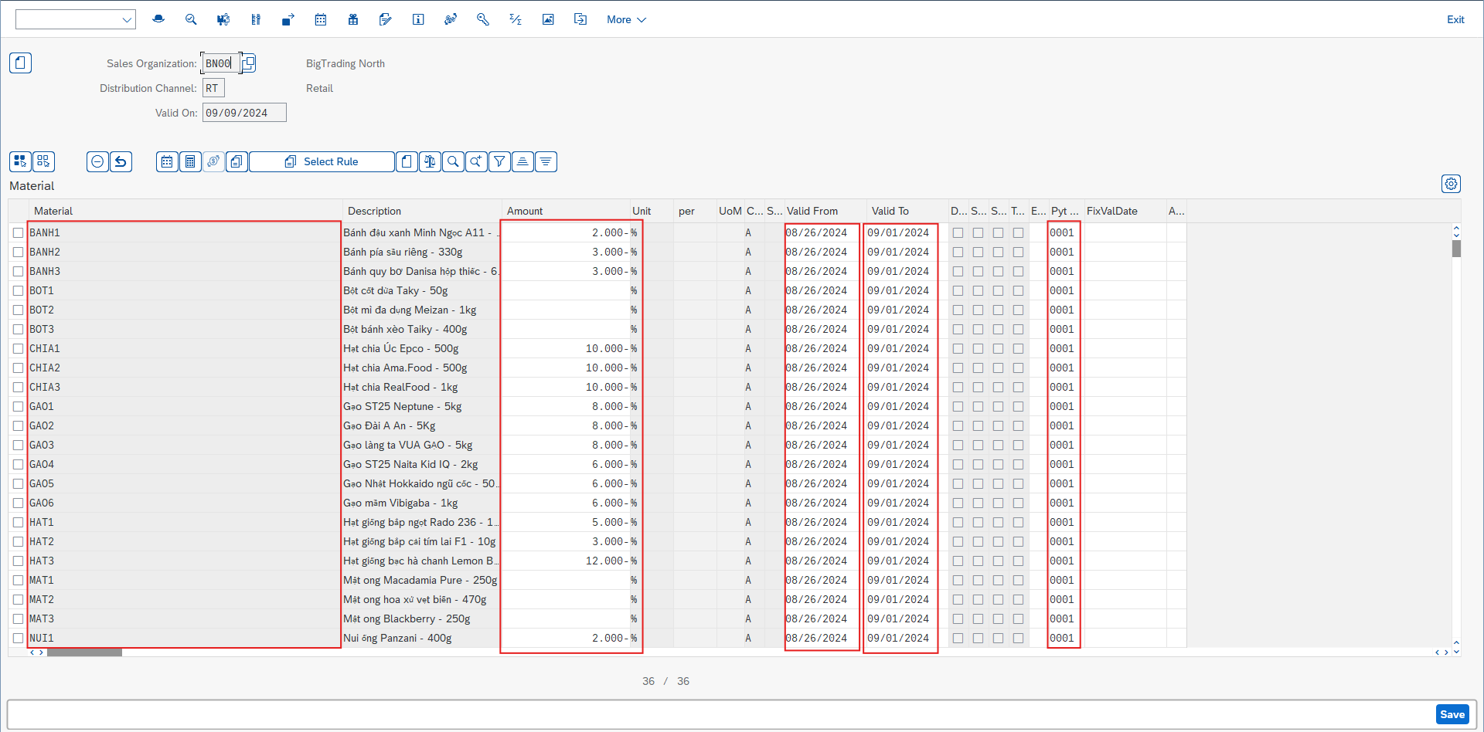

Process Execution

1. Direct Sales Process

1.1 Create Sales Order
Create a sales order from a contract created in the previous task. The system copies all relevant data from the referenced document.
In the SAP Easy Access menu, follow the menu path:
SAP menu ► Logistics ► Sales and Distribution ► Sales ► Order ► Create
T-Code: VA01
Step 1: In the Create Sales Documents screen, enter the following information:
Attribute | Data Value
Order Type | ZVT1
Sales Organization | VT01
Distribution Channel | VW
Division | CB

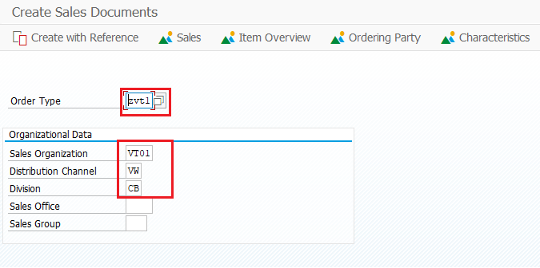
Step 2: Click Enter.
Step 3: Enter information as following:
Attribute | Data Value
Sold-to Party | 100121
Ship-to Party | 100121
Cust. Reference | 100121
Pyt Terms | ZVT1
Incoterms | FEV
Material | 650
Order Quantity | 1
Sales Unit | Pal
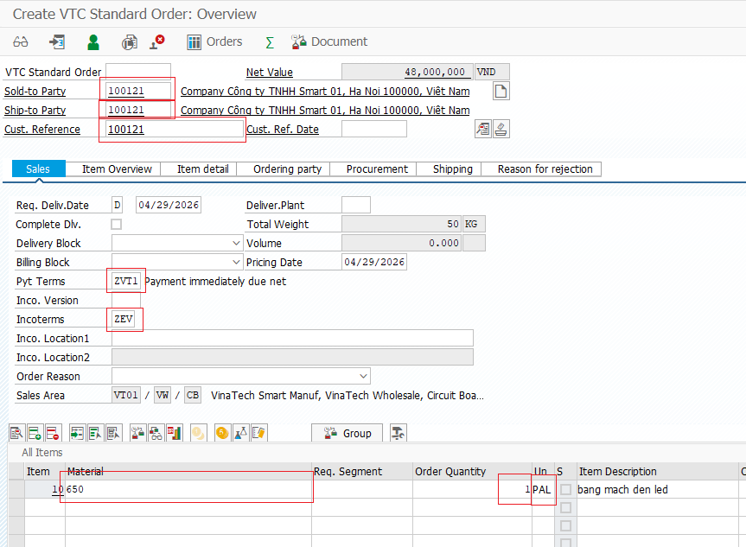
Step 4: Click on “Display header details”
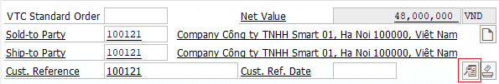
Step 5: Check Conditions
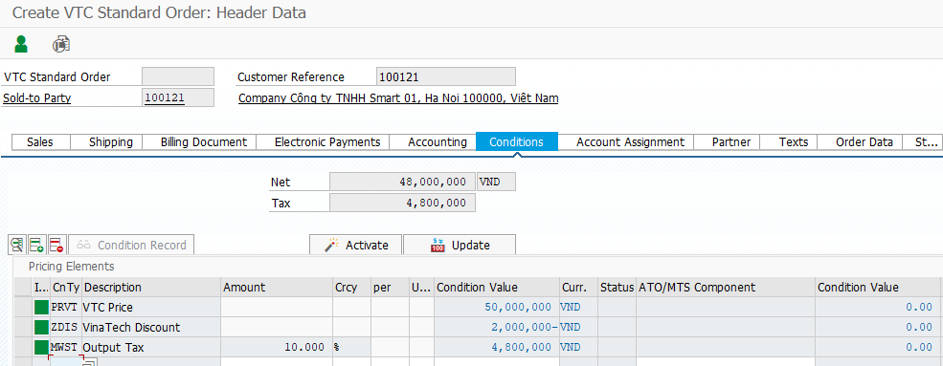
Step 6: Click on 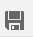. You will receive a message that says 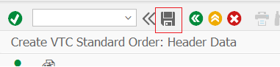
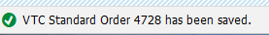.
Step 7: Click on to return to the SAP Easy Access menu.

1.2 Create Outbound Delivery
Ship the order that your customer requested by creating an outbound delivery. Can create a single outbound delivery for exactly one order, if you know the order number. Only the order items from this order that are due for shipment will be included in the delivery.
In the SAP Easy Access menu, follow the menu path:
SAP menu ► Logistics ► Sales and Distribution ► Shipping and Transportation ► Outbound Delivery ► Create ► Single Document ► With Reference to Sales Order
T-Code: VL01n
Step 1: In the Create Outbound Delivery with Order Reference screen, enter the following information:
Attribute | Data value
Shipping Point | SP02
Selection Date | Time after Today
Order | 4728

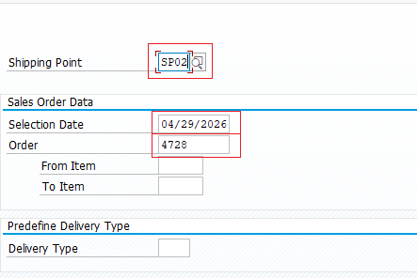
*Delivery Selection Date: The date with which you select the delivery that you want to process.
Step 2: In the Outbound Delivery Create: Overview screen, click on the Picking tab and enter the following information:
Attribute | SLoc | Picked Qty
650 | FG01 | 1

*Document Date: The document date is the date on which the original document was issued.
*Pick Date/Time: The number that uniquely identifies the delivery
*Stag Date: The date by which picking must begin for the delivery item to reach the customer on time
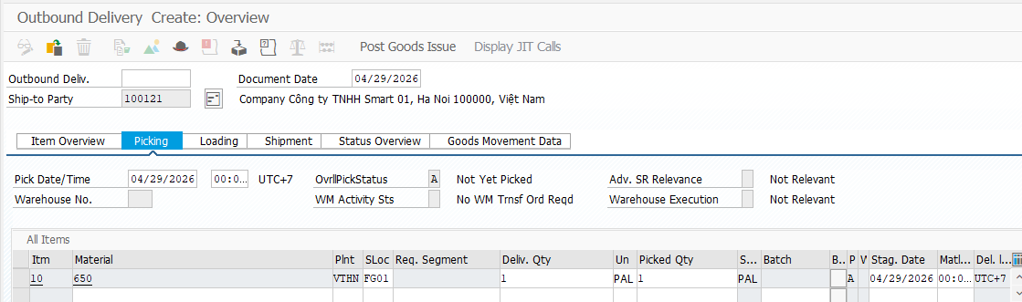
Step 3: Click on Loading, fill Loading Date
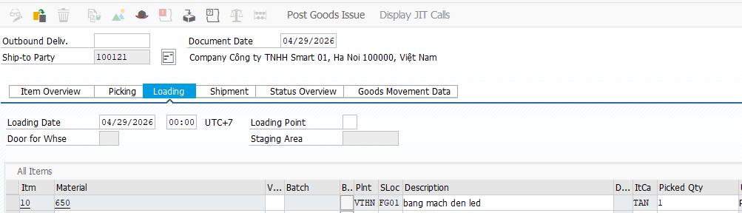
*Loading Date: The date by which picking and packing must be completed so that the goods are ready for loading and for the delivery to reach the customer on time. Any special packaging materials required for loading must also be available by this date.
Step 4: Click on Shipment, fill TransptnPlanng.
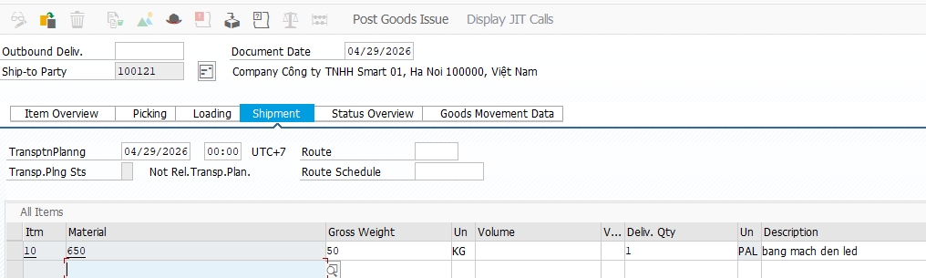
*TransptnPlanng (Transportation Planning Date): The date by which you must arrange transportation so that the delivery can reach the customer on time.
Step 5: Click on Item Overview, fill Planned GI and Actual GI Date.
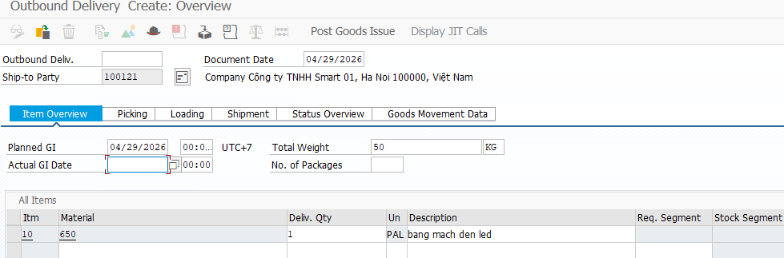

*Planned GI: The date on which the goods must physically leave the shipping point to reach the customer on time.
*Actual Goods Movement Date: You can set the posting date for goods movement to match the actual goods movement date, even for previous periods. If not specified, the system uses the current date. The posting date is based on the goods movement date, while the document date reflects the current date.
Step 6: Click on 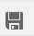 . You will receive a message that says .
Step 7: Click on to return to the SAP Easy Access menu.

1.3 Post Good Issue OD
Post your goods issue. Creating the post goods issue (shipping) reduces unrestricted stock to reflect the quantity shipped. It also indicates a change in the ownership of the goods. In order to post goods issue, all necessary shipping activities must be completed. These activities include entering all necessary data in the outbound delivery.
In the SAP Easy Access menu, follow the menu path:
SAP menu ► Logistics ► Sales and Distribution ► Shipping and Transportation ► Outbound Delivery ► Change ► Single Document
T-Code: VL02n
Step 1: In the Change Outbound Delivery screen, enter your Delivery Number and click on the 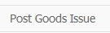 icon.
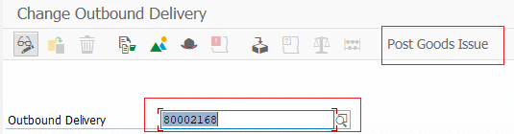
Step 2: You will receive a message that says .
Step 3: Click on to return to the SAP Easy Access menu.

1.4 Create Invoice
Create a customer invoice to send to your customer for the goods. Once the post goods issue has been generated, you can bill your customer for the shipped goods. A bill is also known as an invoice. It is a document that contains information about a transaction between a seller and a buyer. An invoice will consist of significant information like the price and date of a purchase.
In the SAP Easy Access menu, follow the menu path:
SAP menu ► Logistics ► Sales and Distribution ► Billing ► Billing Document ► Create
T-Code: VF01
Step 1: In the Create Billing Document screen, enter your Delivery Number in the column Document and click Enter.
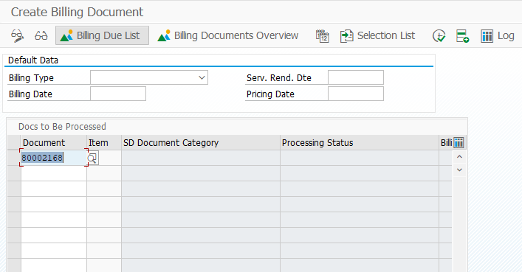
Step 2: Check informations about invoice:
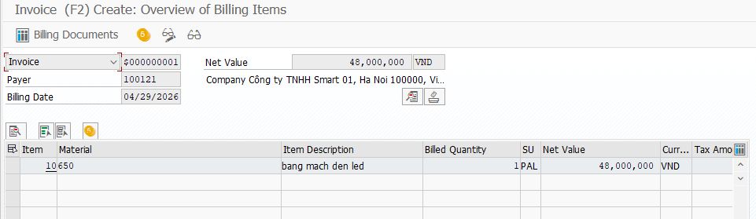
Step 3: Click 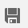, you will receive a message that says
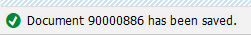.
Step 4: Click on to return to the SAP Easy Access menu.

1.5 Receive Payment
Post the received customer payment. Your customer has received the invoice and sent you its payment. The incoming payment will be posted to the company’s general ledger account. The general ledger is the company’s main accounting records.
In the SAP Easy Access menu, follow the menu path:
SAP menu ► Accounting ► Financial Accounting ► Accounts Receivables ► Document Entry ► Incoming Payments
T-Code: F-28
Step 1: In the Post Incoming Payments: Header Data screen, enter the following information:
Attribute | Data Value
Document Date | 04/29/2026
Posting Date | 04/29/2026
Type | DZ
Period | 9
Company Code | VTC1
Currency | VND
Bank data: House Bank | VTB1
Account | 100000
Amount | 52,800,000
Open item selection: Account | 100121

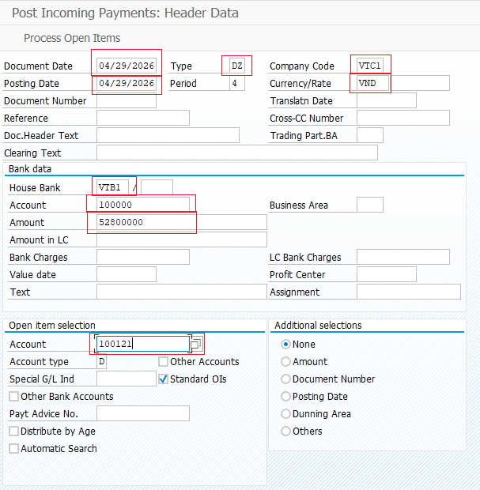
Step 2: Click on the 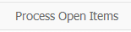 icon and Check Information below:
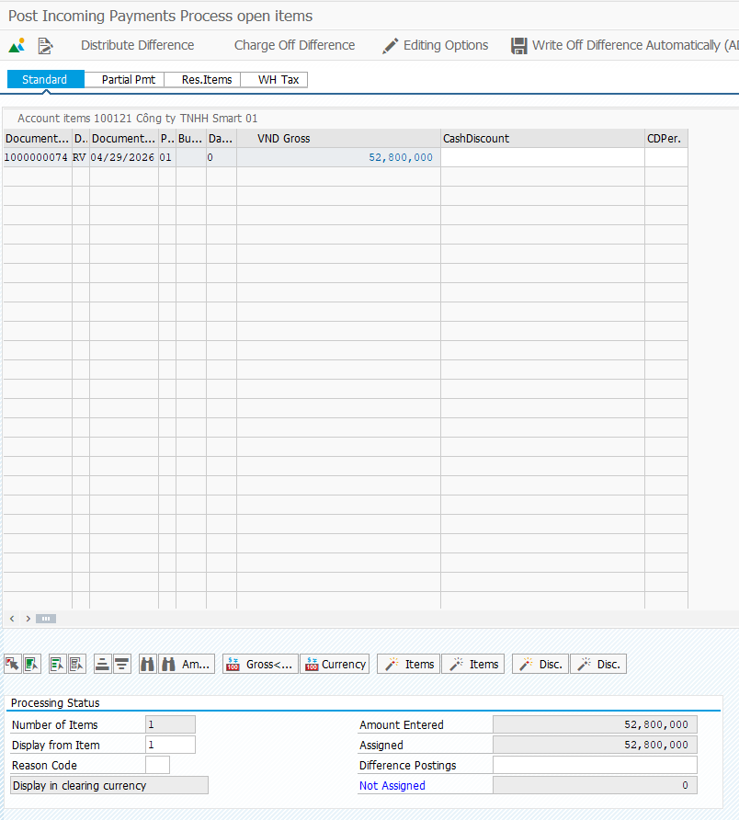
Step 3: In the Post Incoming Payments Process open items screen, click on the 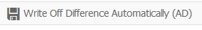 icon.
Step 4: You will receive a message that says
.
Step 5: Click on 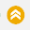 to return to the SAP Easy Access menu.

2. Sales Return - Different Period

2.1 Create Sales Order
Create a sales order from a contract created in the previous task. The system copies all relevant data from the referenced document.
In the SAP Easy Access menu, follow the menu path:
SAP menu ► Logistics ► Sales and Distribution ► Sales ► Order ► Create
T-Code: VA01
Step 1: In the Create Sales Documents screen, enter the following information:
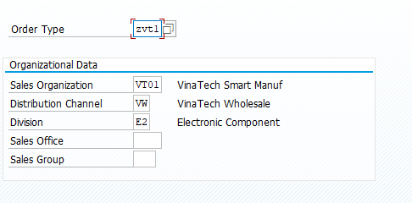
Step 2: Click Enter.
Step 3: Enter information as following:
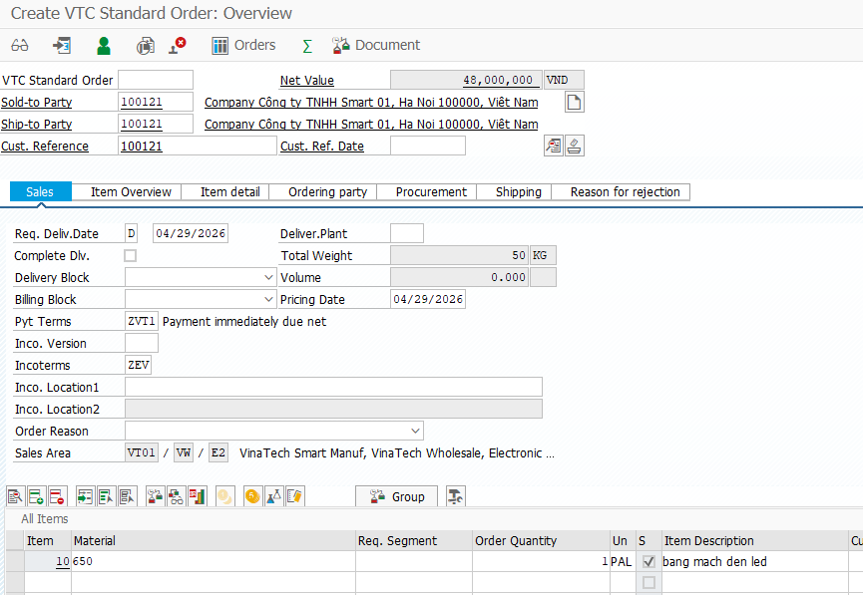
Step 4: Click on . You will receive a message that says .
Step 10: Click on to return to the SAP Easy Access menu.

2.2 Create Outbound Delivery
Ship the order that your customer requested by creating an outbound delivery. Can create a single outbound delivery for exactly one order, if you know the order number. Only the order items from this order that are due for shipment will be included in the delivery. You can make changes to the shipping data if necessary such as storage location.
In the SAP Easy Access menu, follow the menu path:
SAP menu ► Logistics ► Sales and Distribution ► Shipping and Transportation ► Outbound Delivery ► Create ► Single Document ► With Reference to Sales Order
T-Code: VL01n
Step 1: In the Create Outbound Delivery with Order Reference screen, enter the following information:
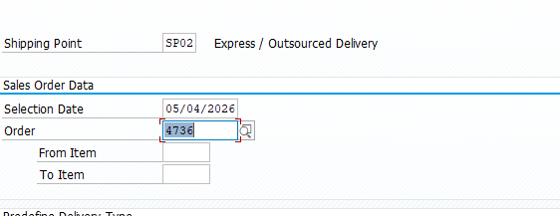
*Delivery Selection Date: The date with which you select the delivery that you want to process.
Step 2: In the Outbound Delivery Create: Overview screen, click on the Picking tab and enter the following information:
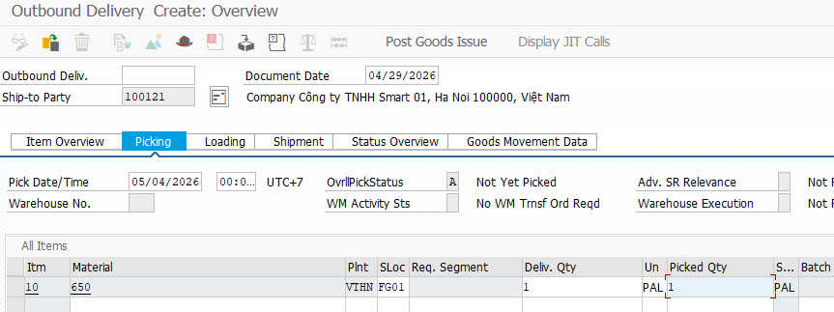
*Document Date: The document date is the date on which the original document was issued.
*Pick Date/Time: The number that uniquely identifies the delivery
*Stag Date: The date by which picking must begin for the delivery item to reach the customer on time
Step 3: Click on Loading, fill Loading Date
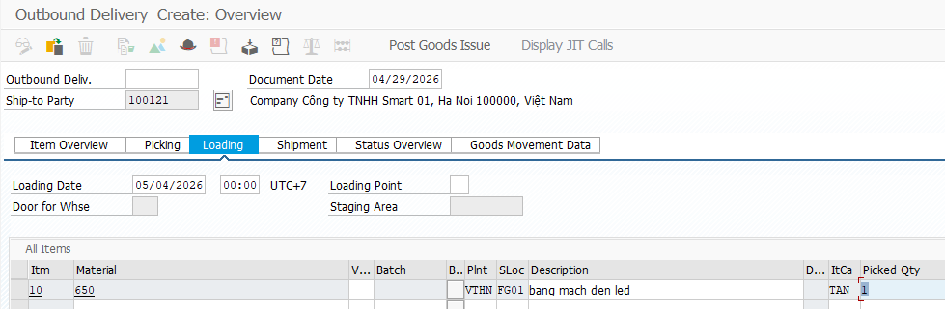
*Loading Date: The date by which picking and packing must be completed so that the goods are ready for loading and for the delivery to reach the customer on time. Any special packaging materials required for loading must also be available by this date.
Step 4: Click on Shipment, fill TransptnPlanng.
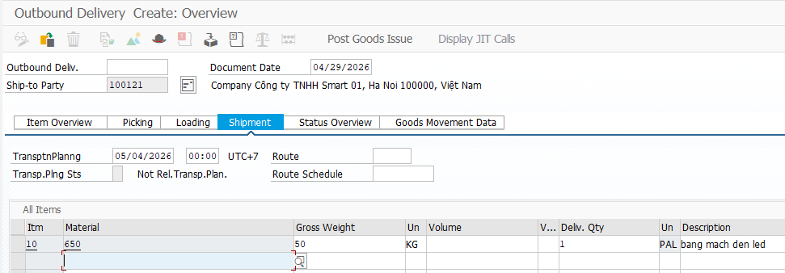
*TransptnPlanng (Transportation Planning Date): The date by which you must arrange transportation so that the delivery can reach the customer on time.
Step 5: Click on Item Overview, fill Planned GI.
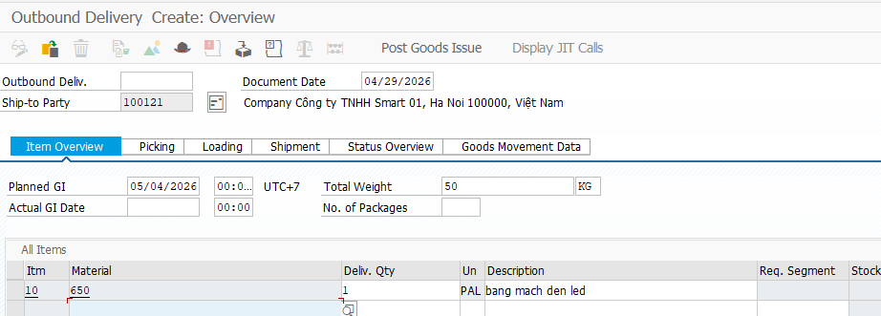
*Planned GI: The date on which the goods must physically leave the shipping point to reach the customer on time.
*Actual Goods Movement Date: You can set the posting date for goods movement to match the actual goods movement date, even for previous periods. If not specified, the system uses the current date. The posting date is based on the goods movement date, while the document date reflects the current date.
Step 6: Click on 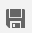. You will receive a message that says .
Step 7: Click on to return to the SAP Easy Access menu.

2.3 Post Good Issue OD
Post your goods issue. Creating the post goods issue (shipping) reduces unrestricted stock to reflect the quantity shipped. It also indicates a change in the ownership of the goods. In order to post goods issue, all necessary shipping activities must be completed. These activities include entering all necessary data in the outbound delivery.
In the SAP Easy Access menu, follow the menu path:
SAP menu ► Logistics ► Sales and Distribution ► Shipping and Transportation ► Outbound Delivery ► Change ► Single Document
T-Code: VL02n
Step 1: In the Change Outbound Delivery screen, enter your Delivery Number and click on the icon.
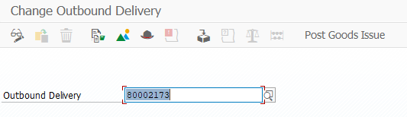
Step 2: You will receive a message that says .
Step 3: Click on to return to the SAP Easy Access menu.

2.4 Create Invoice
Create a customer invoice to send to your customer for the goods. Once the post goods issue has been generated, you can bill your customer for the shipped goods. A bill is also known as an invoice. It is a document that contains information about a transaction between a seller and a buyer. An invoice will consist of significant information like the price and date of a purchase.
In the SAP Easy Access menu, follow the menu path:
SAP menu ► Logistics ► Sales and Distribution ►Sales ► Order ► Subsequence Functions ► Billing Document
TCODE: VF01
Step 1: In the Create Billing Document screen, enter your Delivery Number in the column Document and Enter.
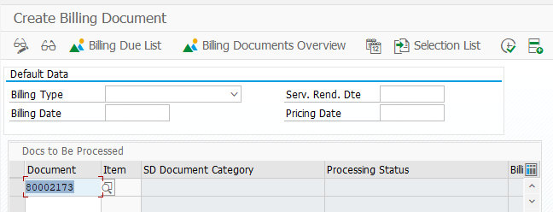
Step 2: Check informations about invoice:
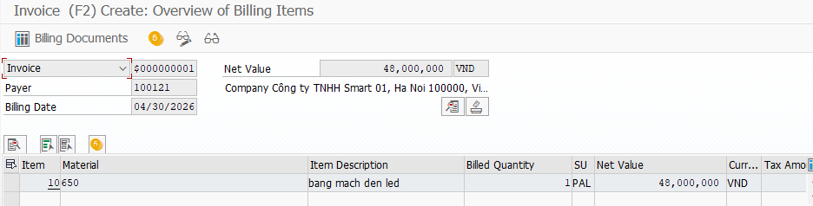
Step 3: Click on the icon and you will receive a message that says .
Step 4: Click on to return to the SAP Easy Access menu.

2.5 Receive Payment
Post the received customer payment. Your customer has received the invoice and sent you its payment. The incoming payment will be posted to the company’s general ledger account. The general ledger is the company’s main accounting records.
In the SAP Easy Access menu, follow the menu path:
SAP menu ► Accounting ► Financial Accounting ► Accounts Receivables ► Document Entry ► Incoming Payments
T-Code: F-28
Attribute | Data Value
Document Date | 04/29/2026
Posting Date | 04/29/2026
Type | DZ
Company Code | VTC1
Currency | VND
Bank data: House Bank | VTB1
Account | 100000
Amount | 52,800,000
Open item selection: Account | 100121

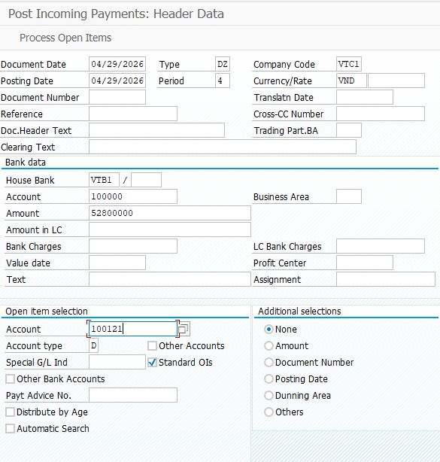
Step 2: Click on the  icon and Check Information below:
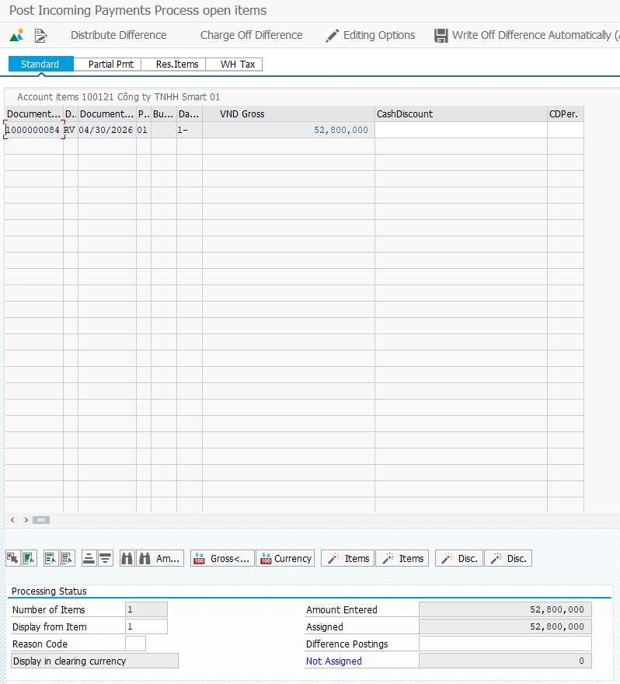
Step 3: In the Post Incoming Payments Process open items screen, click on the  icon.
Step 4: You will receive a message that says
Step 5: Click on  to return to the SAP Easy Access menu.

2.6 Create Sales Return
Create a sales order from a contract created in the previous task. The system copies all relevant data from the referenced document.
In the SAP Easy Access menu, follow the menu path:
SAP menu ► Logistics ► Sales and Distribution ► Sales ► Order ► Create
T-Code: VA01
Step 1: In the Create Sales Documents screen, enter the following information:
Attribute | Data Value
Order Type | ZVT2
Sales Organization | VT01
Distribution Channel | VW
Division | CB
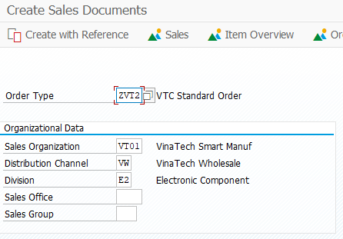
Step 2: Click on 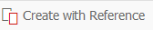
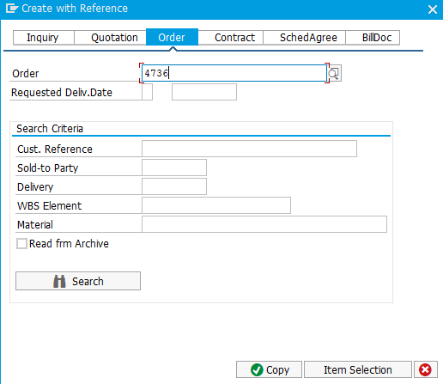
Step 3: Enter information as following:
Attribute | Data Value
Order Reason | Chose Reason

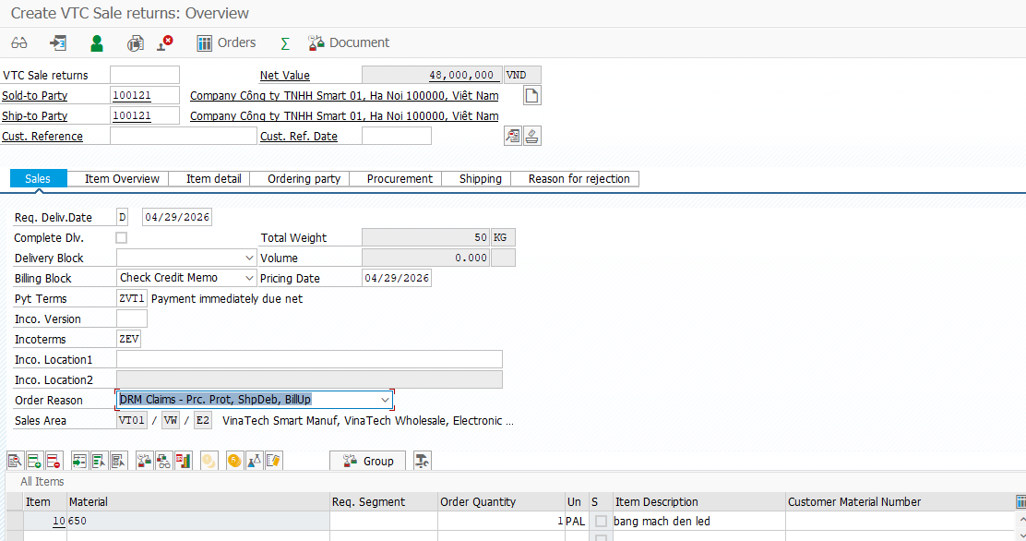
Step 4: Click on Conditions - Depend on Product (check procedure and condition of price)
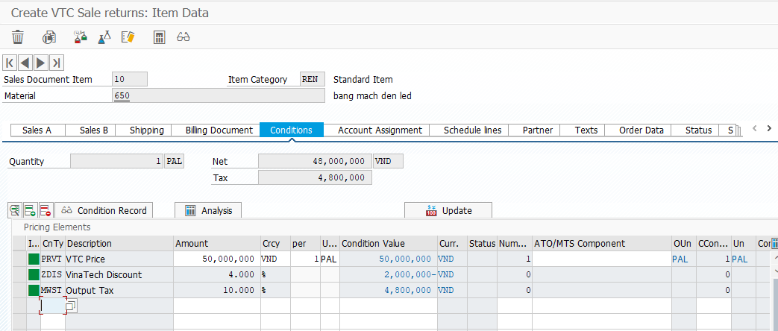
Step 5: Click on . You will receive a message that says
.
Step 6: Click on to return to the SAP Easy Access menu.

2.7 Create Return Delivery
Ship the order that your customer requested by creating an outbound delivery. Can create a single outbound delivery for exactly one order, if you know the order number. Only the order items from this order that are due for shipment will be included in the delivery.
In the SAP Easy Access menu, follow the menu path:
SAP menu ► Logistics ► Sales and Distribution ► Shipping and Transportation ► Outbound Delivery ► Create ► Single Document ► With Reference to Sales Order
T-Code: VL01n
Step 1: In the Create Outbound Delivery with Order Reference screen, enter the following information:
Attribute | Data value
Shipping Point | SP02
Selection Date | Time after Today
Order | 60000198
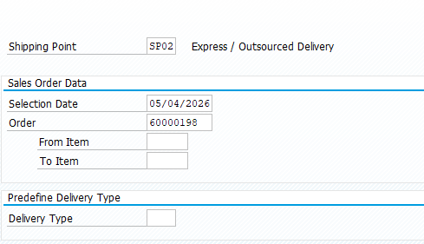
*Delivery Selection Date: The date with which you select the delivery that you want to process.
Step 2: In the Return Delivery Create: Overview screen, click on the Picking tab and enter the following information:
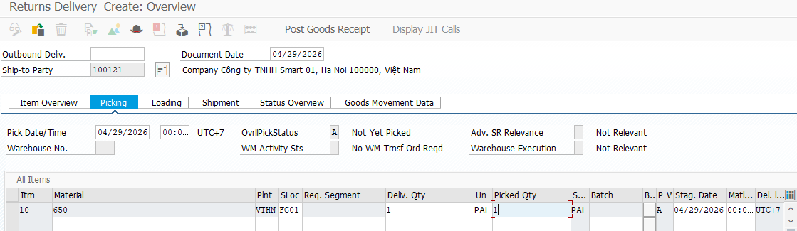
Step 3: Click on Loading, fill Loading Date
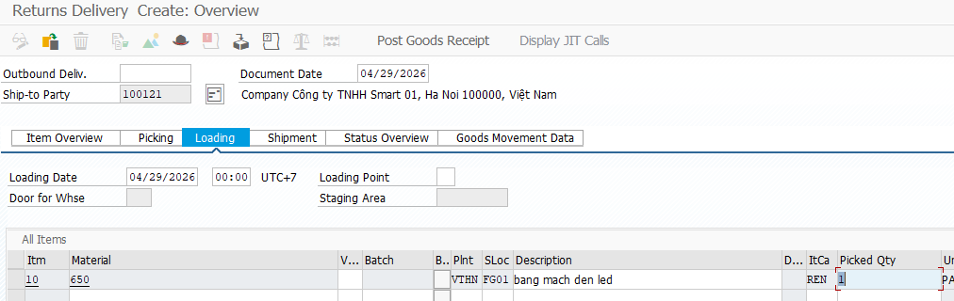
*Loading Date: The date by which picking and packing must be completed so that the goods are ready for loading and for the delivery to reach the customer on time. Any special packaging materials required for loading must also be available by this date.
Step 4: Click on Shipment, fill TransptnPlanng.
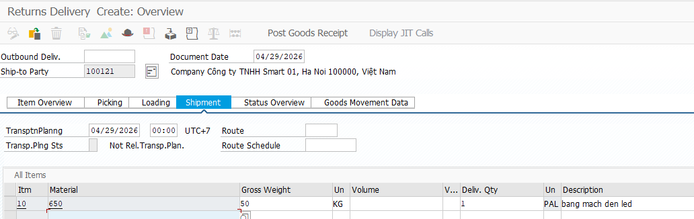
*TransptnPlanng (Transportation Planning Date): The date by which you must arrange transportation so that the delivery can reach the customer on time.
Step 5: Click on Item Overview, fill Planned GI.
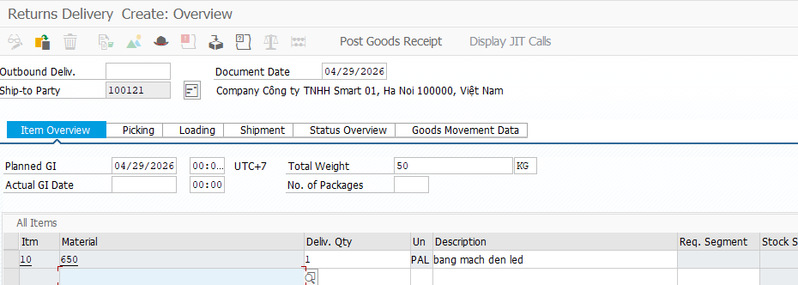
*Planned GI: The date on which the goods must physically leave the shipping point to reach the customer on time.
*Actual Goods Movement Date: You can set the posting date for goods movement to match the actual goods movement date, even for previous periods. If not specified, the system uses the current date. The posting date is based on the goods movement date, while the document date reflects the current date.
Step 6: Click on . You will receive a message that says 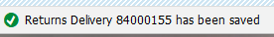.
Step 7: Click on to return to the SAP Easy Access menu.

2.8 Post Goods Receipt
Post your goods issue. Creating the post goods issue (shipping) reduces unrestricted stock to reflect the quantity shipped. It also indicates a change in the ownership of the goods. In order to post goods issue, all necessary shipping activities must be completed. These activities include entering all necessary data in the outbound delivery.
In the SAP Easy Access menu, follow the menu path:
SAP menu ► Logistics ► Sales and Distribution ► Shipping and Transportation ► Outbound Delivery ► Change ► Single Document
T-Code: VL02n
Step 1: In the Change Outbound Delivery screen, enter your Delivery Number and click on the 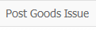 icon.
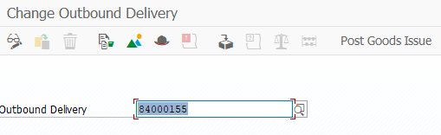
Step 2: You will receive a message that says
.
Step 3: Click on to return to the SAP Easy Access menu.

2.9 Check Billing Document

Create a customer invoice to send to your customer for the goods. Once the post goods issue has been generated, you can bill your customer for the shipped goods. A bill is also known as an invoice. It is a document that contains information about a transaction between a seller and a buyer. An invoice will consist of significant information like the price and date of a purchase.
In the SAP Easy Access menu, follow the menu path:
SAP menu ► Logistics ► Sales and Distribution ►Sales ► Order ► Subsequence Functions ► Billing Document
T-Code: VF01
Step 1: In the Create Billing Document screen, enter your Delivery Number in the column Document and Enter.
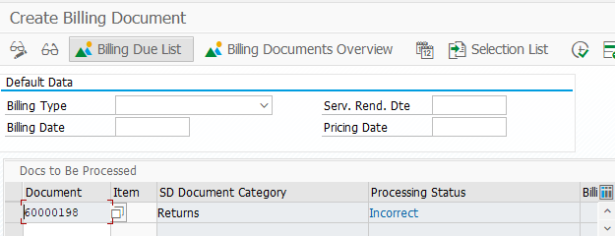
Step 2: Click on 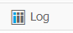and receive error:
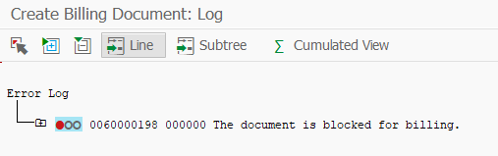
Step 3: Click on to return to the SAP Easy Access menu.

2.10 Remove Billing Block
Create a return order that returns the item on the original sales order.
In the SAP Easy Access menu, follow the menu path:
SAP menu ► Logistics ► Sales and Distribution ► Sales ► Order ► Change
T-Code: VA02
Step 1: View “Change Sales Documents” and press Enter
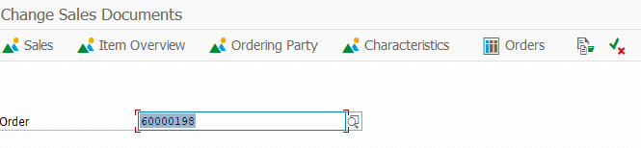
Step 2: Choose Billing Block
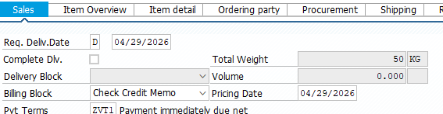
Step 3: Clear Billing Block:
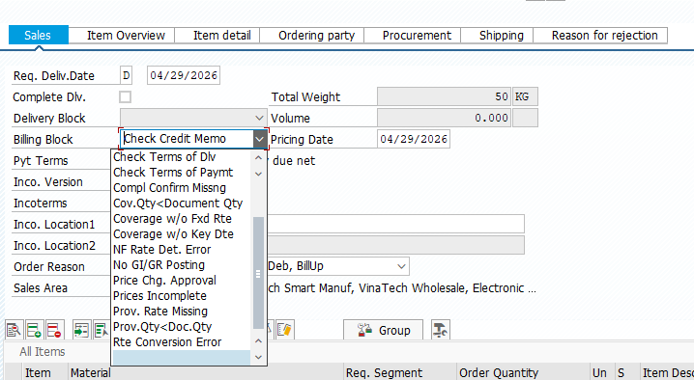
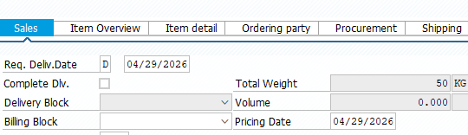
Step 4: Click on 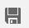. You will receive a message that says
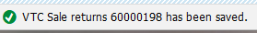 .
Step 5: Click on to return to the SAP Easy Access menu.

2.11 Create Invoice
Create a customer invoice to send to your customer for the goods. Once the post goods issue has been generated, you can bill your customer for the shipped goods. A bill is also known as an invoice. It is a document that contains information about a transaction between a seller and a buyer. An invoice will consist of significant information like the price and date of a purchase.
In the SAP Easy Access menu, follow the menu path:
SAP menu ► Logistics ► Sales and Distribution ►Sales ► Order ► Subsequence Functions ► Billing Document
T-Code: VF01
Step 1: In the Create Billing Document screen, enter your Delivery Number in the column Document and Enter.
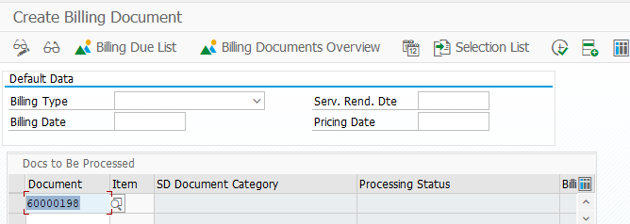
Step 2: Check informations about invoice:
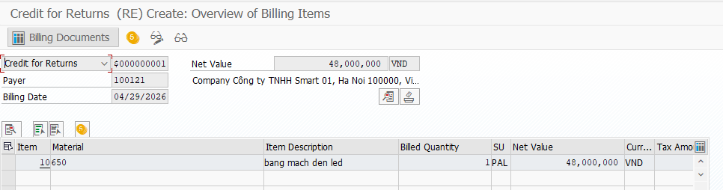
Step 3: Click on the icon and you will receive a message that says 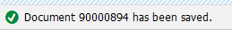
Step 4: Click on to return to the SAP Easy Access menu.

2.12 Receive Payment
Post the received customer payment. Your customer has received the invoice and sent you its payment. The incoming payment will be posted to the company’s general ledger account. The general ledger is the company’s main accounting records.
In the SAP Easy Access menu, follow the menu path:
SAP menu ► Accounting ► Financial Accounting ► Accounts Receivables ► Document Entry ► Incoming Payments
T-Code: F-28
Step 1: In the Post Incoming Payments: Header Data screen, enter the following information:
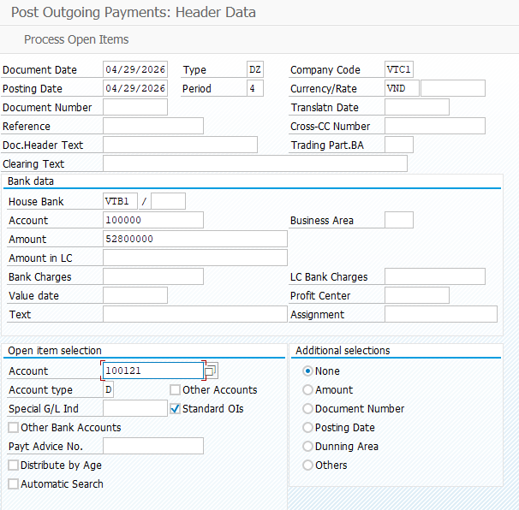
Step 2: Click Enter. You will receive a message that says “Amount is zero - line item will be ignored”. Click Enter again.
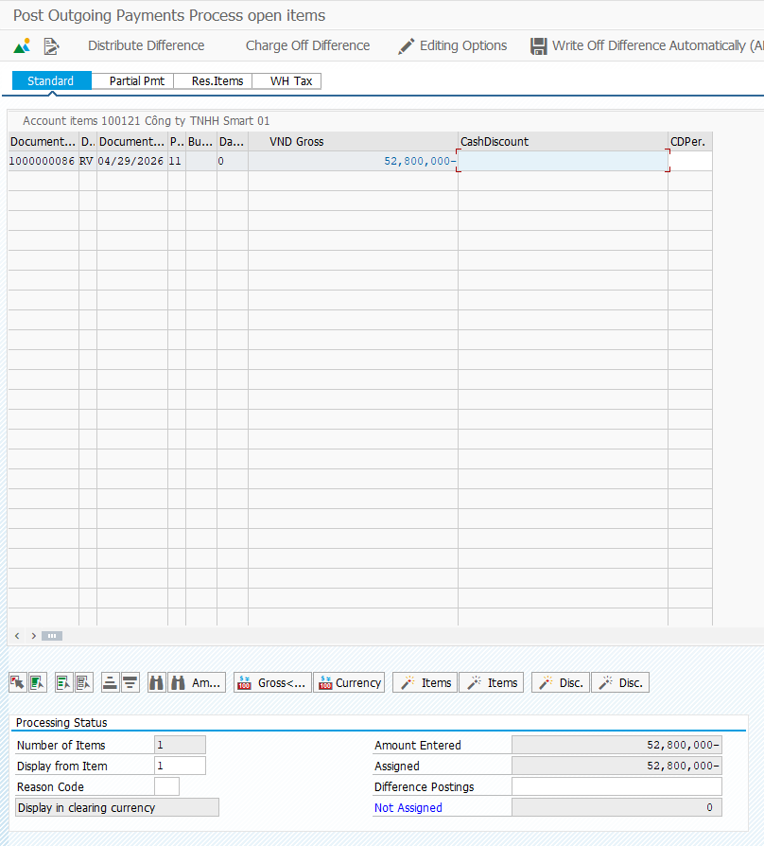
Step 3: In the Post Incoming Payments Process open items screen, click on the icon.
Step 4: You will receive a message that says
.
Step 5: Click on to return to the SAP Easy Access menu.

3. Sales Return - Same Period

3.1 Create Sales Order

Create a sales order from a contract created in the previous task. The system copies all relevant data from the referenced document.
In the SAP Easy Access menu, follow the menu path:
SAP menu ► Logistics ► Sales and Distribution ► Sales ► Order ► Create
T-Code: VA01
Step 1: In the Create Sales Documents screen, enter the following information:
Attribute | Data Value
Order Type | ZVT1
Sales Organization | VT01
Distribution Channel | VW
Division | CB

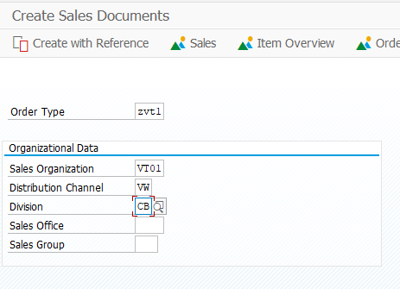
Step 2: Click on Enter.
Step 3: Enter information as following:
Attribute | Data Value
Sold-to Party | 100121
Ship-to Party | 100121
Cust. Reference | 100121
Pyt Terms | ZVT1
Incoterms | FEV
Material | 650
Order Quantity | 1
Sales Unit | Pal

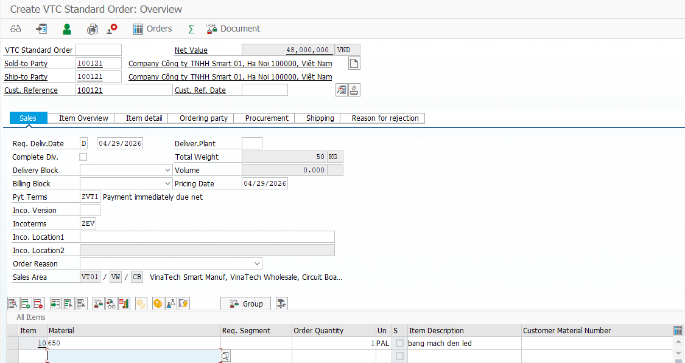
Step 4: Click on 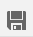. You will receive a message that says
.
Step 5: Click on to return to the SAP Easy Access menu.

3.2 Create Outbound Delivery
Ship the order that your customer requested by creating an outbound delivery. Can create a single outbound delivery for exactly one order, if you know the order number. Only the order items from this order that are due for shipment will be included in the delivery.
In the SAP Easy Access menu, follow the menu path:
SAP menu ► Logistics ► Sales and Distribution ► Shipping and Transportation ► Outbound Delivery ► Create ► Single Document ► With Reference to Sales Order
TCODE: VL01n
Step 1: In the Create Outbound Delivery with Order Reference screen, enter the following information:
Attribute | Data value
Shipping Point | SP02
Selection Date | Time After Today
Order | 4729

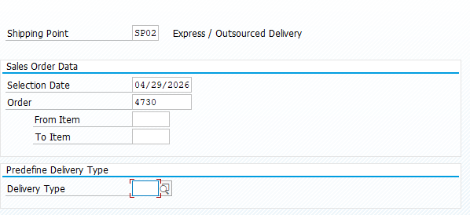
Step 2: In the Outbound Delivery Create: Overview screen, click on the Picking tab and enter the following information:

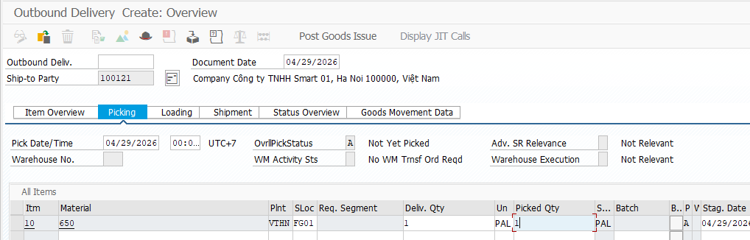
*Document Date: The document date is the date on which the original document was issued.
*Pick Date/Time: The number that uniquely identifies the delivery
*Stag Date: The date by which picking must begin for the delivery item to reach the customer on time
Step 3: Click on Loading, fill Loading Date
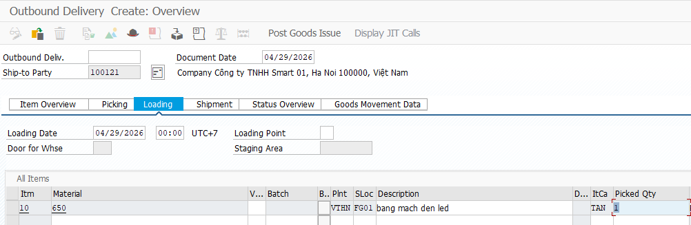
*Loading Date: The date by which picking and packing must be completed so that the goods are ready for loading and for the delivery to reach the customer on time. Any special packaging materials required for loading must also be available by this date.
Step 4: Click on Shipment, fill TransptnPlanng.
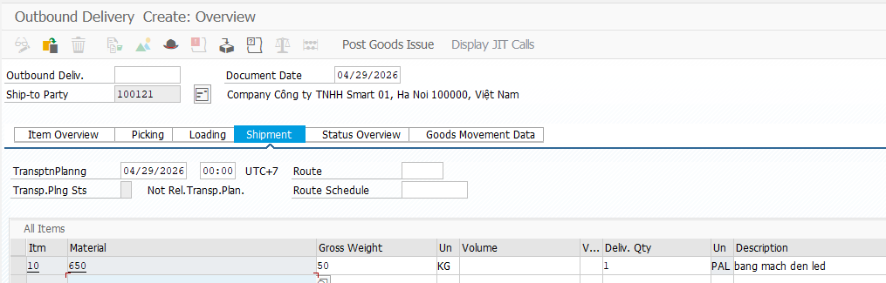
*TransptnPlanng (Transportation Planning Date): The date by which you must arrange transportation so that the delivery can reach the customer on time.
Step 5: Click on Item Overview, fill Planned GI.
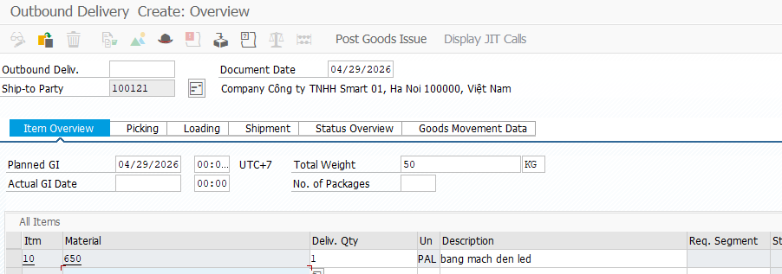
*Planned GI: The date on which the goods must physically leave the shipping point to reach the customer on time.
*Actual Goods Movement Date: You can set the posting date for goods movement to match the actual goods movement date, even for previous periods. If not specified, the system uses the current date. The posting date is based on the goods movement date, while the document date reflects the current date.
Step 6: Click on . You will receive a message that says .
Step 7: Click on to return to the SAP Easy Access menu.

3.3 Post Good Issue OD
Post your goods issue. Creating the post goods issue (shipping) reduces unrestricted stock to reflect the quantity shipped. It also indicates a change in the ownership of the goods. In order to post goods issue, all necessary shipping activities must be completed. These activities include entering all necessary data in the outbound delivery.
In the SAP Easy Access menu, follow the menu path:
SAP menu ► Logistics ► Sales and Distribution ► Shipping and Transportation ► Outbound Delivery ► Change ► Single Document
T-Code: VL02n
Step 1: In the Change Outbound Delivery screen, enter your Delivery Number and click on the 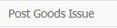 icon.
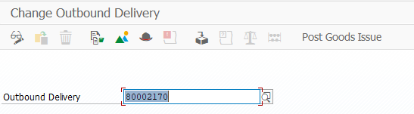
Step 2: You will receive a message that says .
Step 3: Click on to return to the SAP Easy Access menu.

3.4 Create Invoice
Create a customer invoice to send to your customer for the goods. Once the post goods issue has been generated, you can bill your customer for the shipped goods. A bill is also known as an invoice. It is a document that contains information about a transaction between a seller and a buyer. An invoice will consist of significant information like the price and date of a purchase.
In the SAP Easy Access menu, follow the menu path:
SAP menu ► Logistics ► Sales and Distribution ►Sales ► Order ► Subsequence Functions ► Billing Document
T-Code: VF01
Step 1: In the Create Billing Document screen, enter your Delivery Number in the column Document and Enter.
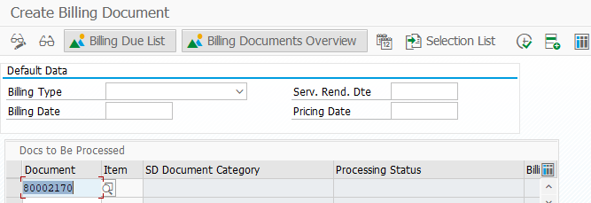
Step 2: Check informations about invoice:
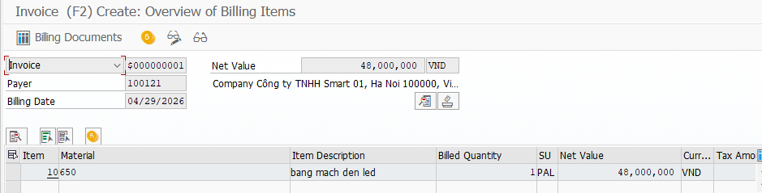
Step 3: Click on the 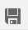 icon and you will receive a message that says .
Step 4: Click on to return to the SAP Easy Access menu.

3.5 Create Sales Return
Create a sales order from a contract created in the previous task. The system copies all relevant data from the referenced document.
In the SAP Easy Access menu, follow the menu path:
SAP menu ► Logistics ► Sales and Distribution ► Sales ► Order ► Create
T-Code: VA01
Step 1: In the Create Sales Documents screen, enter the following information:
Attribute | Data Value
Order Type | ZVT2
Sales Organization | VT01
Distribution Channel | VW
Division | CB
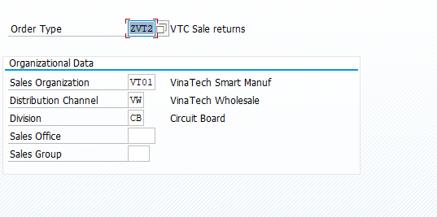
Step 2: Click on 
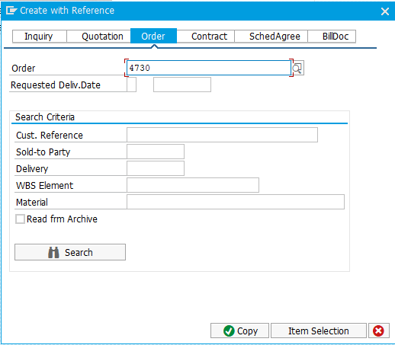
Step 3: Enter information as following:
Attribute | Data Value
Order Reason | Chose Reason
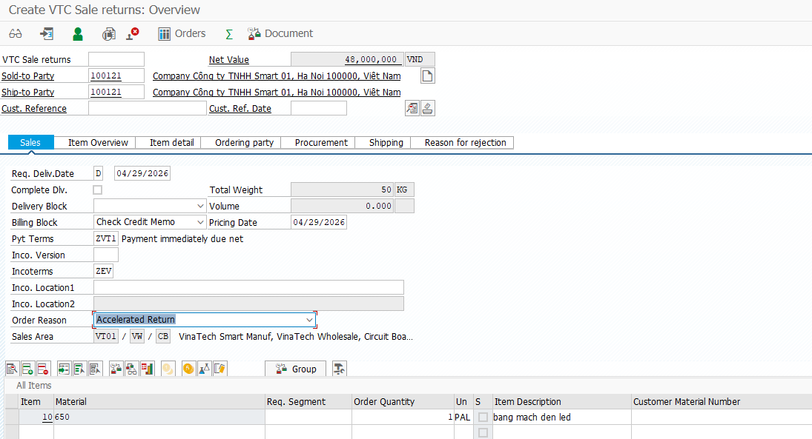

Step 4: Click on Conditions - Depend on Product (check procedure and condition of price)
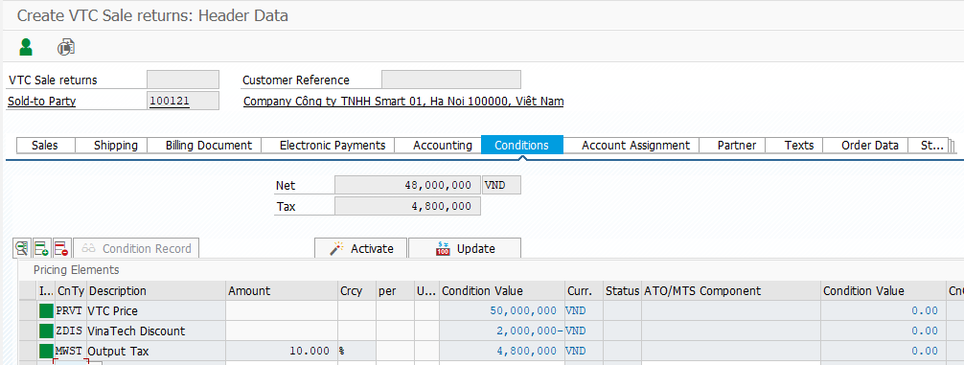
Step 5: Click on . You will receive a message that says
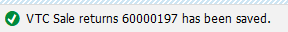 .
Step 6: Click on to return to the SAP Easy Access menu.

3.6 Create Return Delivery
Ship the order that your customer requested by creating an outbound delivery. Can create a single outbound delivery for exactly one order, if you know the order number. Only the order items from this order that are due for shipment will be included in the delivery.
In the SAP Easy Access menu, follow the menu path:
SAP menu ► Logistics ► Sales and Distribution ► Shipping and Transportation ► Outbound Delivery ► Create ► Single Document ► With Reference to Sales Order
T-Code: VL01n
Step 1: In the Create Outbound Delivery with Order Reference screen, enter the following information:
Attribute | Data value
Shipping Point | SP02
Selection Date | Time after Today
Order | 60000197
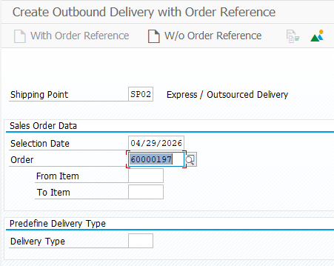
*Delivery Selection Date: The date with which you select the delivery that you want to process.
Step 2: In the Return Delivery Create: Overview screen, click on the Picking tab and enter the following information:
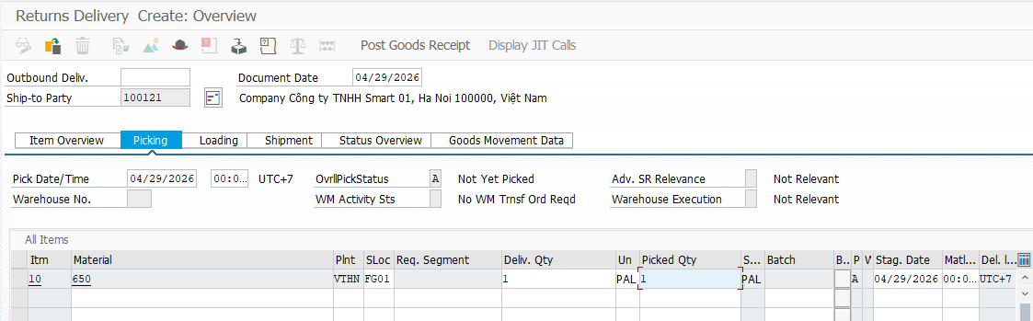
Step 3: Click on Loading, fill Loading Date
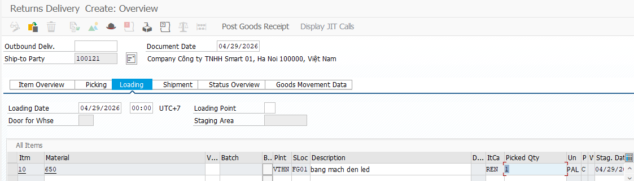
*Loading Date: The date by which picking and packing must be completed so that the goods are ready for loading and for the delivery to reach the customer on time. Any special packaging materials required for loading must also be available by this date.
Step 4: Click on Shipment, fill TransptnPlanng.
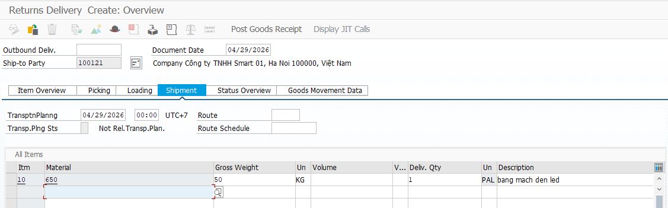
*TransptnPlanng (Transportation Planning Date): The date by which you must arrange transportation so that the delivery can reach the customer on time.
Step 5: Click on Item Overview, fill Planned GI.
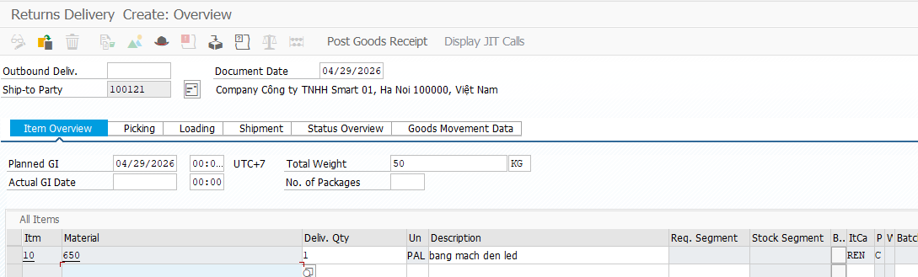
*Planned GI: The date on which the goods must physically leave the shipping point to reach the customer on time.
*Actual Goods Movement Date: You can set the posting date for goods movement to match the actual goods movement date, even for previous periods. If not specified, the system uses the current date. The posting date is based on the goods movement date, while the document date reflects the current date.
Step 6: Click on . You will receive a message that says .
Step 7: Click on to return to the SAP Easy Access menu.

3.7 Post Goods Receipt
Post your goods issue. Creating the post goods issue (shipping) reduces unrestricted stock to reflect the quantity shipped. It also indicates a change in the ownership of the goods. In order to post goods issue, all necessary shipping activities must be completed. These activities include entering all necessary data in the outbound delivery.
In the SAP Easy Access menu, follow the menu path:
SAP menu ► Logistics ► Sales and Distribution ► Shipping and Transportation ► Outbound Delivery ► Change ► Single Document
T-Code: VL02n
Step 1: In the Change Outbound Delivery screen, enter your Delivery Number and click on the  icon.
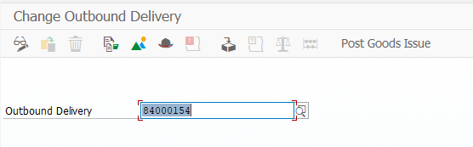
Step 2: You will receive a message that says
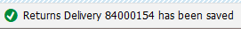 .
Step 3: Click on to return to the SAP Easy Access menu.

3.8 Check Billing Document
Create a customer invoice to send to your customer for the goods. Once the post goods issue has been generated, you can bill your customer for the shipped goods. A bill is also known as an invoice. It is a document that contains information about a transaction between a seller and a buyer. An invoice will consist of significant information like the price and date of a purchase.
In the SAP Easy Access menu, follow the menu path:
SAP menu ► Logistics ► Sales and Distribution ►Sales ► Order ► Subsequence Functions ► Billing Document
T-Code: VF01
Step 1: In the Create Billing Document screen, enter your Delivery Number in the column Document and Enter.
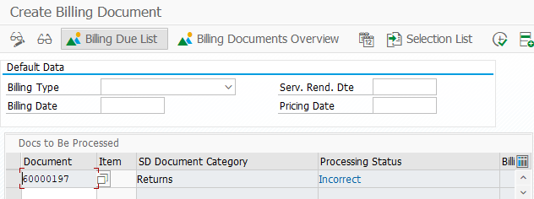
Step 2: Click on and receive error:
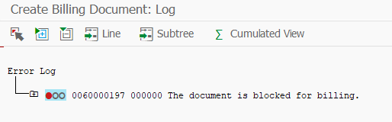
Step 3: Click on to return to the SAP Easy Access menu.

3.9 Remove Billing Block
Create a return order that returns the item on the original sales order.
In the SAP Easy Access menu, follow the menu path:
SAP menu ► Logistics ► Sales and Distribution ► Sales ► Order ► Change
T-Code: VA02
Step 1: View “Change Sales Documents” and press Enter
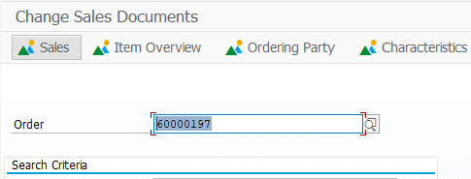

Step 2: Choose Billing Block
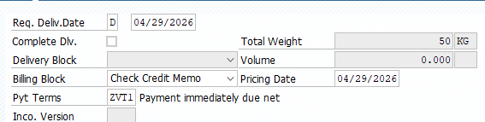
Step 3: Clear Billing Block:
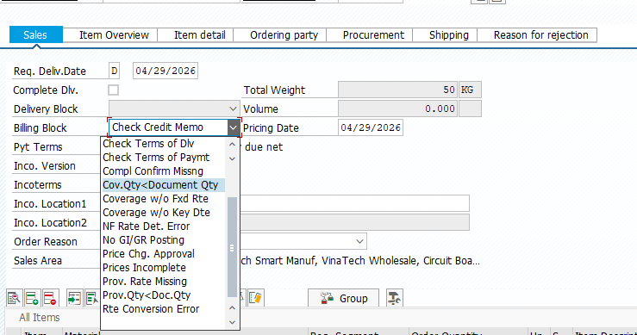
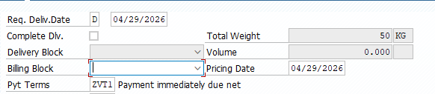
Step 4: Click on . You will receive a message that says
.
Step 5: Click on to return to the SAP Easy Access menu.

3.10 Create Invoice
Create a customer invoice to send to your customer for the goods. Once the post goods issue has been generated, you can bill your customer for the shipped goods. A bill is also known as an invoice. It is a document that contains information about a transaction between a seller and a buyer. An invoice will consist of significant information like the price and date of a purchase.
In the SAP Easy Access menu, follow the menu path:
SAP menu ► Logistics ► Sales and Distribution ►Sales ► Order ► Subsequence Functions ► Billing Document
T-Code: VF01
Step 1: In the Create Billing Document screen, enter your Delivery Number in the column Document and Enter.
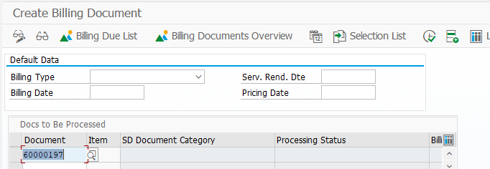
Step 2: Check informations about invoice:
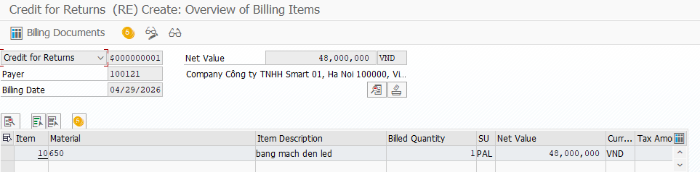
Step 3: Click on the icon and you will receive a message that says
Step 4: Click on to return to the SAP Easy Access menu.

3.11 Receive Payment
Post the received customer payment. Your customer has received the invoice and sent you its payment. The incoming payment will be posted to the company’s general ledger account. The general ledger is the company’s main accounting records.
In the SAP Easy Access menu, follow the menu path:
SAP menu ► Accounting ► Financial Accounting ► Accounts Receivables ► Document Entry ► Incoming Payments
T-Code: F-28
Step 1: In the Post Incoming Payments: Header Data screen, enter the following information:
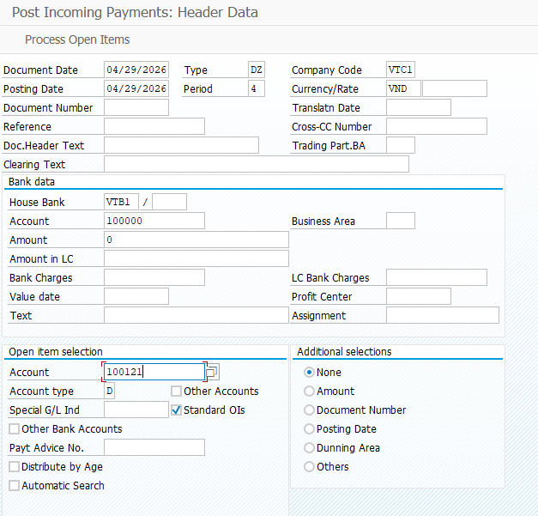
Step 2: Click Enter. You will receive a message that says “Amount is zero - line item will be ignored”. Click Enter again.
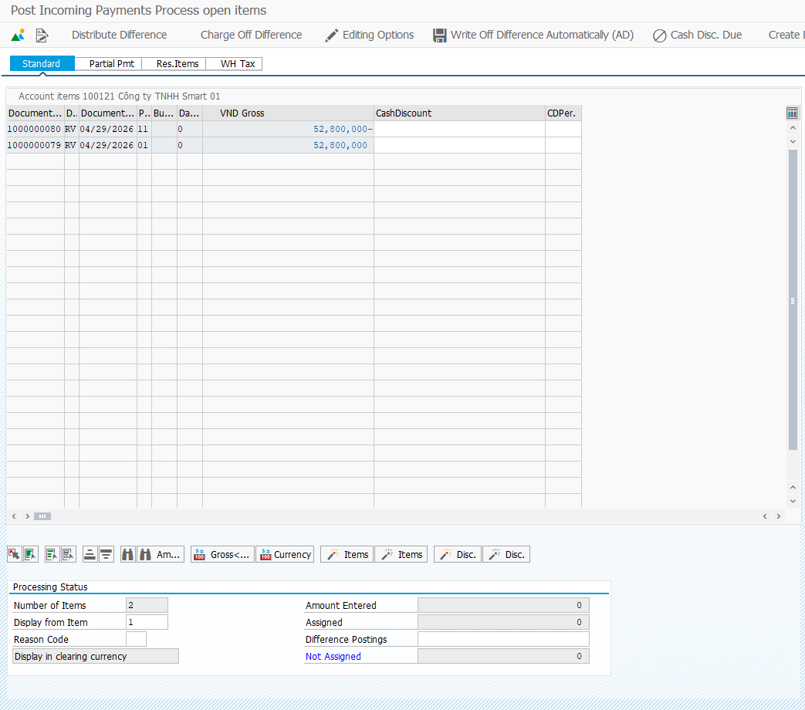
Step 3: In the Post Incoming Payments Process open items screen, click on the icon.
Step 4: You will receive a message that says
.
Step 5: Click on to return to the SAP Easy Access menu.

